Assignment One

**Learning Tasks 1 – 5 and Analytical Reflection**

by

Alan Hubbard

S326012

for

Dr Khyiah Angel

ECM241 Teaching the Curriculum: Junior Secondary Digital Technology

Learning Task 1 – Concept Map

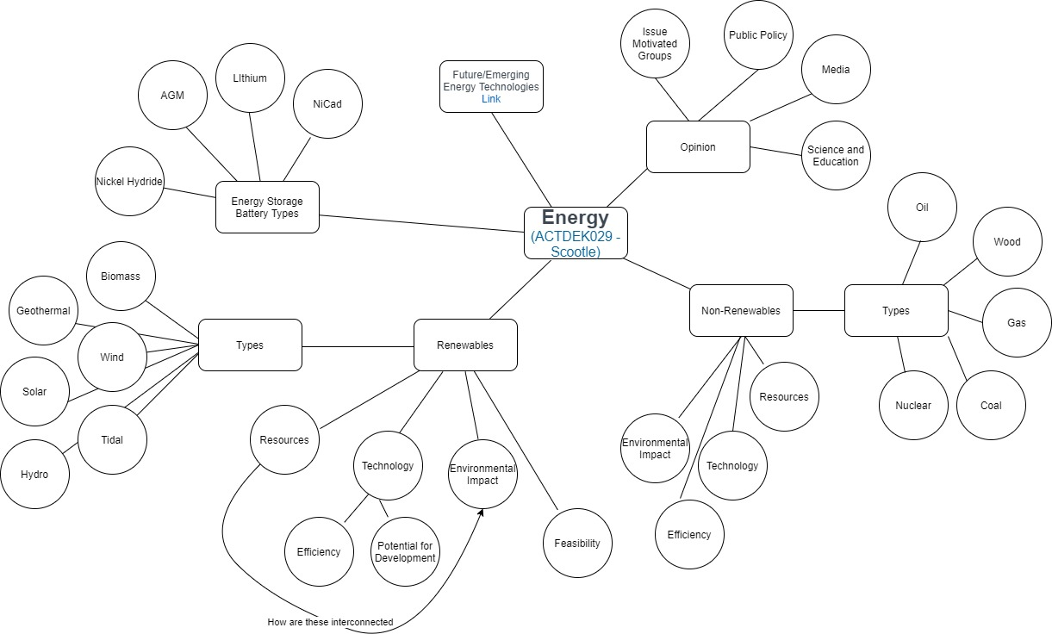

Learning Task 2 - Prepare a summary of one teaching model.

This activity is an online learning platform, that teaches from basics of coding and ICT skills. Specifically, for this activity, students will be focused on learning how to write python script. This teaching technique is no limited to Grok Learning; other popular platforms are Code Academy and Code.org.

This activity capitalises on the interest of students within the online and digital world, and as such, the content is developed in a purely online interface. Students are able to conduct self-paced learning, as they are taught through the platform and are tested regularly to confirm learning. The testing is conducted in two formats. The first, is through formative assessment, where learners are given problems designed to develop problem solving based on short lessons already taught. These assessments are not pass or fail but are used to confirm they are understood the content. The second assessment does not allow for any assistance and are part of their summative grade. Further, their attempts at the summative assessments are limited, forcing more deliberate critical thinking.

This activity is based on Technological, pedagogical and Content Knowledge (TPACK) framework, specifically technological. Students will be able to relate the skills learnt through other subjects and general capabilities, in particular ICT Capability. The use of the online interface is familiar to 21st Century Learners therefore capitalising on their interests and strengths.

This activity is an online learning platform, that teaches from basics of coding and ICT skills. Specifically, for this activity, students will be focused on learning how to write python script. This teaching technique is no limited to Grok Learning; other popular platforms are Code Academy and Code.org.

This activity capitalises on the interest of students within the online and digital world, and as such, the content is developed in a purely online interface. Students are able to conduct self-paced learning, as they are taught through the platform and are tested regularly to confirm learning. The testing is conducted in two formats. The first, is through formative assessment, where learners are given problems designed to develop problem solving based on short lessons already taught. These assessments are not pass or fail but are used to confirm they are understood the content. The second assessment does not allow for any assistance and are part of their summative grade. Further, their attempts at the summative assessments are limited, forcing more deliberate critical thinking.

This activity is based on Technological, pedagogical and Content Knowledge (TPACK) framework, specifically technological. Students will be able to relate the skills learnt through other subjects and general capabilities, in particular ICT Capability. The use of the online interface is familiar to 21st Century Learners therefore capitalising on their interests and strengths.

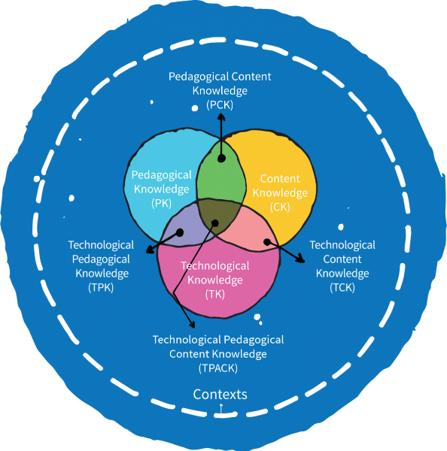

Resources

GROK Learning. (n.d.) *Learn to Code from your browser.* <https://groklearning.com/>

Codecademy. (n.d.) *Learn Python 2.* <https://www.codecademy.com/learn/learn-python>

Code.org. (n.d.) *Learn today, build a brighter tomorrow.* <https://code.org/>

Learning task 3: Prepare an activity focusing on learning outcomes for indigenous students.

This activity specifically targets the construct/deconstruct portion of the 8Ways pedagogy. It can also be used through lank links, by identifying how and where native bees live and how they may have been used in traditional horticulture.

Students will be presented with resources that show a completed beehive, designs and instructions for building the beehive. They will also be able to deconstruct an example beehive, if they choose to, in order to investigate how it was constructed. The activity will be designed to allow for students to individually explore the beehive construction as well as be shown how to construct before attempting themselves, it if they choose. It will also be designed to allow for group and individual discussions, to allow for the development of ideas and/or methods to complete the activity.

The project allows for investigation using natural products and may also allow for exploration and discussion of sustainable practices. This will consider our connection and responsibility to the environment, which can be related to Land Links from 8Ways Online.

Learning Intention – Students will investigate native beehive materials and construction, and choose or design a beehive, that they will construct.

Introduction – Show students how native bees produce “sugar bag” (the term for native bees’ honey) and their effect on the environment. [Video](https://www.youtube.com/watch?v=xH7pk4XjZDs) watch up to 2:00. Remainder can be watched during body of the lesson if desirable.

Show a constructed beehive and diagrams or blueprints on their construction.

Body – Students will be allowed to investigate in groups or individually: the materials used and required, the various designs, natural beehives and how to construct a beehive. Students will also have the opportunity to find their own resources for the beehive.

Conclusion – Students review and discuss what materials they intend to use to construct their beehive and the plan they have chosen or designed themselves.

References and Resources

8 WAYS. (n.d.) *8 Aboriginal Ways of Learning. Aboriginal Pedagogy.* <https://www.8ways.online/>

Aussie Bee. (n.d.) *Hive Design for Stingless Bees*. <https://www.aussiebee.com.au/hive-designs-stingless-bees.html>

Native Bee Hives. (n.d.) *Box Building Archives*. <https://www.nativebeehives.com/category/box-building/>

Treehugger. (n.d.) *How to Build a Hotel for Wild Bees*. <https://www.treehugger.com/how-build-hotel-wild-bees-4863814>

Australian Stringless Native Bees. (n.d.) *Resources*. <https://zabel.com.au/australian-stingless-native-bees/ressources/>

Learning task 4: Prepare a lesson plan, write all resources, concepts, language needs required to deliver this lesson.

See attached in separate document.

Learning task 5: Give peer feedback on lesson plans.

Excellent integration of local context into a familiar and popular digital technology. The consideration and justification of sustainable resource use, shows a desire to reach across the curriculum.

Consider how the hook is going to engage the students’ attention and if there are other ways to do so. Have you thought about how students, that do not complete the task can complete them at a later stage?

Throughout this lesson plan it is evident there have been many considerations to ensure the success of the outcomes and lesson. Great work.

Part B: Analytical Reflection

Word Count: 1230

The use and integration of ICT in the classroom is critical for the development of students adapt to the rapid changes occurring within, not only the Digital Technologies and Technologies areas, but in wider society (Hernandez, 2017). This includes an inclusion of sustainability and developing solutions toward it. Further, the systematic and organised approach to the use of technology within the classroom is critical to the success of students and their education within the modern era (Lazar, 2015). It is, therefore, critical, that educators and administrations, are able to include new and developing technologies within the classroom to provide students with the best opportunities to either, enter the workforce or continue higher and other forms of education.

The two learning tasks selected for Part B of this assignment are Learning Task 3: Prepare an activity that focuses on learning outcomes for indigenous students Learning Task 4: Prepare and original lesson plan.

The learning outcomes for Learning Task 3 was to identify the materials and methods to construct a native beehive and choose or design a beehive to construct. The challenges for this activity, to be discussed, are the connection to local context and ensuring students understand the connections to complex multifaceted issues, whilst remaining focused on achieving a specified outcome.

The breadth of potential outcomes for this activity can be defined or limited by either the teacher or students. The aim of the activity description was to allow for the greatest number of options for the class to explore through their own discovery (Bamiro, 2015). Specifically, this area of interest can explore the design of a beehive through the use of tools such as Revit and CAD or the concept of sustainability, by using natural resources and sustainable living practices. This concept allows firstly the teacher to remain within an area that is familiar, therefore can provide suitable guidance, but secondly and most importantly, both students and teachers can explore new ideas that they were previously unaware of. This encourages a deeper more authentic learning process therefore a deeper understanding of the content and issues involved.

This activity can be used to relate to specific local contexts through the exploration of sustainability and the use of 8 Ways Learning (n.d.). This further reinforces the relevance of the content and provides another avenue to engage the learners. The continued use of European Honeybees in commercial and, increasingly, residential means, is creating potential for disease, similar to that seen overseas. The reinvigoration of the native bee improves natural ecosystem stabilisation and reduces the potential of disease outbreak in honeybees.

The learning outcome Learning Task 4 was to control and program an RPA, where students would be required to be able to manoeuvre the RPA using throttle, yaw, pitch and roll, then progress to programming the RPA to conducted automated manoeuvres. The challenges, to be discussed, are the safety architecture required to conduct these types of activities, classroom management and the progression of learning goals within the Digital Technologies curriculum.

The safety requirements surrounding the control and use of Remotely Piloted Aircraft (RPA) is complex without any prior knowledge. Although all the information is readily available on CASA websites, without some familiarity of laws, rules and regulations, surrounding the use of public airspace, this lesson or the unit of work it could be nested within would not be possible for a teacher to properly or safely deliver to a class. (Civil Aviation Safety Authority, 29 April 2021).

A preferred, and useful, qualification of a Remote Pilot Licence, is fundamental to the basic and background knowledge of this lesson and unit of work. Whilst the course is short, two days, and only addresses basic control of an RPA, it does go into significant detail to laws, rules and regulations that relate to RPA use. Further, it provides the information access so that an RPA pilot can conduct further study into the safe use of and RPA in public. If a Digital Technologies unit is built around the use of RPAs and potentially the accreditation of students with a Remote Pilot Licence, there are a number of civilian contractor solutions available, many of which currently deliver courses to Australian schools.

Classroom management is also critical to the safe operation of an RPA, particularly with students that may be more likely to display more risk-taking behaviour. The lesson plan included a detail diagram to show how the students could be placed to provide sufficient distance between and person and all RPAs. This layout is also useful as one teacher could, depending on student behaviour, manage the entire class from one location, the centre, without being too far from another group.

In order to incorporate these skills within a whole unit of work, there is a need to provide a clear progression of training for students and teachers to deliver the content. As discussed above, the simplest, for teachers and schools is to source a contracted delivery agency to conduct all lessons, provide risk management, provide all resources including RPAs and provide certification of students’ completion through the Civil Aviation Safety Authority (CASA). This is likely expensive therefore planning of delivering a unit of work like this would need approval by school administration well before its commencement and likely before commencing planning the unit.

Sustained collaborative design process. Contextualised and sustained inquiry emerges from authentic design tasks that guide the students towards a deep understanding for increasingly complex real-world problems. The principles of Design based learning, by Baran & Uygun (2016), move through a natural progression, from brainstorming ideas, reviewing artefacts, investigation, review of design principles, applying within context and collaboration within teams. The consistency and relevance of their principles and the Australian Curriculum demonstrate the continuum of learning that is relevant to 21st Century Learners. (Bower, 2017)

These concepts are particularly relevant to the activity described in Learning Task 3, where students are deconstructing and/or investigating the construction of a native beehive. This activity begins at the stage of reviewing the design of technology-integrated artefacts. During this initial stage of the lesson or unit of work, students have the opportunity to investigate the example beehive that is provided. They can also investigate through other sources, most likely through online resources, some of which will be provided. This removes the constraints that the lesson may have placed on the students to be able to explore other designs and re-design them to create their own, which engages with the principle of investigation whilst using ICT tools.

This activity further capitalises on the requirement to include contextual relevance to environmental situations, with education surrounding the native bees. It is well established that students will become more engaged with the content if they self-identify that it is relevant to their situation or circumstance or is contextually relevant. Through this activity students will also learn the importance of native bees to the natural environment and may conduct further investigation to deepen their knowledge and understanding.

The use of technology and ICT tools in the classroom is critical for the success of students’ education within the 21st Century. It is further reinforced by contextual relevance as students understand these requirements and are less likely to engage with the content when contextual relevance is not apparent. Whilst these activities provide opportunity for that relevance to be present, it is the role of the teacher to ensure that it is conveyed in that way.

References

8 WAYS. (n.d.) *8 Aboriginal Ways of Learning. Aboriginal Pedagogy*. <https://www.8ways.online/>

Baran, E., & Uygun, E. (2016). *Putting technological, pedagogical, and content knowledge (TPACK) in action: An integrated TPACK-design-based learning (DBL) approach.* Australasian journal of educational technology, 32(2). <https://doi.org/10.14742/ajet.2551>

Bamiro, A. O. (2015). *Effects of guided discovery and think-pair-share strategies on secondary school students’ achievement in chemistry*. Sage Open, 5(1). <https://doi.org/10.1177/2158244014564754>

Bower, M. (2017). *Design of technology-enhanced learning: Integrating research and practice*. Emerald Group Publishing.

Civil Aviation Safety Authority. (29 April 2021). *Drones*. <https://www.casa.gov.au/drones>

Hernandez, R. M. (2017). *Impact of ICT on Education: Challenges and Perspectives*. Journal of Educational Psychology-Propositos y Representaciones, 5(1), 337-347.

Lazar, S. (2015). *The importance of educational technology in teaching*. International Journal of Cognitive Research in Science, Engineering and Education, 3(1). <https://doi.org/10.23947/2334-8496-2015-3-1-111-114>